- [3] ADSP:
confirm the pins out for U1B
- [4] RAM interface:
confirm the pins out / in for DDR RAM
Vss = 2.5 volt and Vref should be 0.5*vss . he used voltage divider to drop to 1.25 V .
the current value should be insert to Vref pin is 2uA, so the weight of load to voltage divider is very low
https://media.digikey.com/pdf/Data%20Sheets/Micron%20Technology%20Inc%20PDFs/MT46V128M4,_64M8,_32M16.pdf
- [5] FLASH memory
confirm the pins out/in
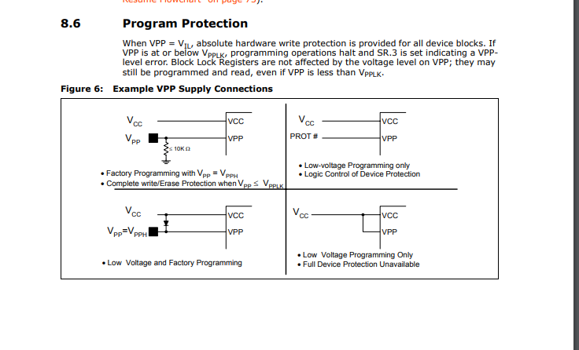
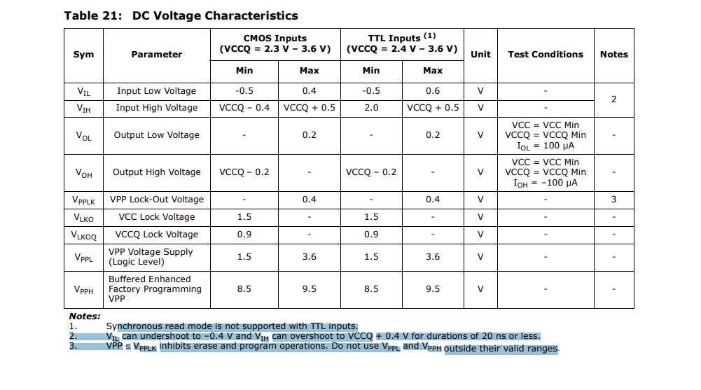
https://media.digikey.com/pdf/Data%20Sheets/Micron%20Technology%20Inc%20PDFs/Flash_Memory_P33-65nm_DS.pdf
4) [6] Boot control
Oscillator: the type of output is TTL , 3.3V Vdd , 0.1uF for elimination the noise (Decoupling ) .. R3=10K to limitation the current from 3.3V
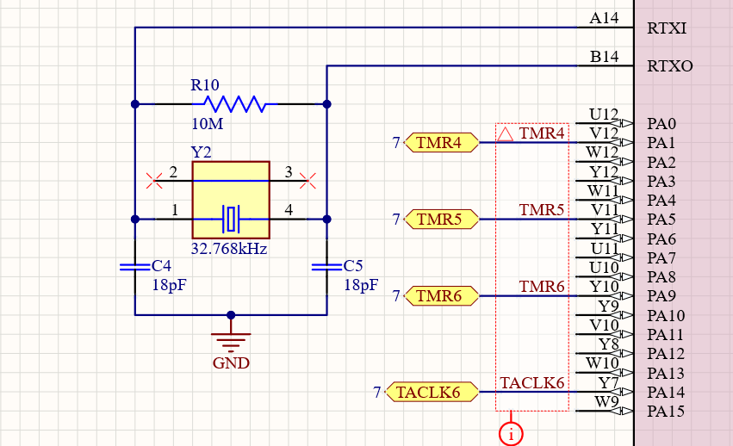
R10 gives the stability for OSC but some circuits is removed. when should I use the RF and what about the effect of IC on the crystal
Does the internal circuit of IC play an important role ?
the mosfet ,regulator,inductor , schottky diode are very large regarding the size and current


